**Network Engineering Capstone  
Project Approval Form**

# Introduction

The purpose of this document is to help you clearly define your capstone project scope and to ensure the project will support the task requirements. Your final network project will be evaluated based on its ability to satisfy 10 test-case scenarios. There are seven predefined test-case scenarios, with the remaining three test cases to be defined by you.

A clearly defined scope is essential for your capstone instructor to accurately assess the validity of your proposed network project and the expected timeline for completion. Work with your instructor before submitting this form if you are unclear on the organizational need or what an appropriately sized network will include. If applicable, scale your network project to no more than that of a 10-user network. A network that is too small will not have all of the connections or devices that are required to validate each of the seven required test cases. A network that is too large will take unnecessary time and effort for you to build, test, and deploy.

Complete this project approval form by identifying the organizational overview, network scope, and network diagram for your proposed network project. Additionally, review the seven predefined test-case scenarios and define three custom test cases to be validated against your network project. Your network project must be built in a virtual lab environment using either GNS3 or Packet Tracer. It is recommended to explore the virtual lab environment and the included GNS3 or Packet Tracer tools during the planning process to ensure alignment between the proposed network project and the available virtual networking tools.

Email this completed form directly to your capstone instructor for approval. Once approved, you will receive a signed document in PDF format that you will upload as part of Task 1.

# Organizational Overview

*Provide one to two paragraphs that describe the organizational need or opportunity that your network will support. If needed, a fictional organization may be used to provide context to the need or opportunity.*

Fenrir Technology Solutions is opening a second location about 15 miles away from their original location. The 10 current employees of Fenrir will be split between these two locations. Employees must be able to securely access network resources from both buildings at any given time. Currently there are 5 employees in sales, 3 in IT, and 2 in management positions.The sales, IT, and management department resources should not be able to be accessed by members of a different team, following the principle of least privilege.

# Network Scope

*Provide one to two paragraphs that describe the main purpose and function of the network that you will build. Additionally, identify a tentative timeline of the anticipated future project start date, end date, and any major milestones to be completed during development.*

The purpose of this network is to provide a reliable way for users from both sites to access each others resources. Not just between the two sites, but also for employees in the same site. This network will feature a layer of core routers, L3 switches, and the access layer switches. Hosts will acquire their IP’s from a DHCP server from the current building. Network devices will be assigned static IP addresses. The new building will use a DHCP relay so users there can also use the existing DHCP server. An IPsec site-to-site VPN will be established for secure communications between sites. OSPF will be the IGP for this network. VLAN’s will be established for layer 2 isolation. 802.1q is in use for trunk ports. Security additions include DAI, DHCP Snooping, ACL’s, and Port Security. Log collection will be handled by Syslog which will provide logs to the specialized logging server. Perimiter devices will use NTP for time synchronization, and should be the lowest stratum possible. RSTP will be utilized for prevention of L2 loops.

Project start date: 4/29/24

Project end date: 10/15/24

Milestones:

Hardware purchased and acquired

Internet accessibility

Dynamic routing/OSPF configured

VLANs/Subnets configured

ACL’s configured

IPsec VPN configured

Port security configured

DHCP configured

# Network Diagram

*Provide a complete graphic diagram of all physical devices and connections for your proposed network.*

*You may use any graphic tool to create this diagram (Visio, PowerPoint, GNS3, etc.), but you must provide a clean and readable image pasted into this approval form (or attached as a PDF) when you submit the form to your instructor.*

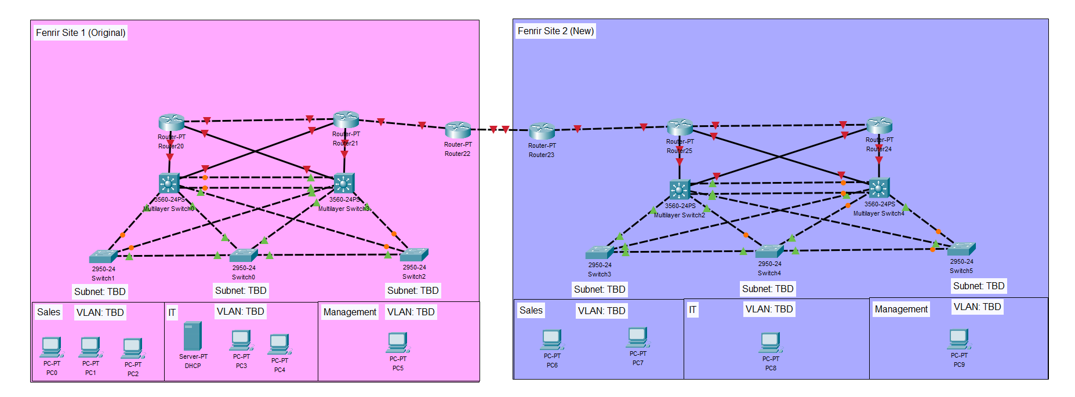

# Test Case Scenarios

## Predefined Test Cases

*Review the seven predefined test-case scenarios to ensure alignment with your proposed network project. Your project will be required to satisfy all seven requirements adapted to your networking use case.*

|  |  |
| --- | --- |
| **TEST CASE** | **REQUIREMENT** |
| **Test Case #1**  **Device Discovery and Reachability** | Your network solution must include multiple network segments with access controls that allow traffic from a device on one network to access the resources of a device on another network. Similarly, there must be devices on one network that cannot access resources on a different network. |
| **Test Case #2**  **Administering an Access Control List for Guest Access** | Your network must utilize an access control list that allows guest access. Guest access should be limited to internet traffic only. |
| **Test Case #3**  **Security Compliance—Log-in Banners** | Display a log-in banner when accessing each device on the network. The log-in banner should notify users of an acceptable use policy (AUP) or other security-based policies when attempting to log into the network. |
| **Test Case #4**  **Accessing External Resources—Routing and Traffic Security** | User devices on your network should have dynamic addresses that are assigned through DHCP unless they provide a service that requires a static address. You must also have at least one network resource that requires a static address. |
| **Test Case #5**  **Layer 2 Link Redundancy and Spanning Tree Protocol (802.1w)** | Enable and manage the Spanning Tree Protocol to establish redundant Layer 2 paths while avoiding possible loops and broadcast storms. Identify the Layer 2 devices that will become the root bridge. |
| **Test Case #6**  **Edge Device Syslog and NTP** | Configure perimeter devices to generate system logs that capture unwanted traffic. Additionally, those perimeter devices should utilize Network Time Protocol (NTP) for clock synchronization. |
| **Test Case #7**  **Basic Network Segmentation at Layer 2 via VLANs and 802.1q** | Your network traffic should be segmented per department or service function at Layer 2 to enhance security and reduce network congestion at the switching layer while allowing segmented traffic to traverse between switches (VLAN trunking). |

## Custom Test Cases

*Define three additional test-case scenarios to be evaluated against your network project. These custom test cases should be equivalent in scope and requirements to the predefined test cases. Additionally, each test case should align to the broad networking domain indicated below.*

|  |  |
| --- | --- |
| **TEST CASE** | **REQUIREMENT** |
| **Test Case #8**  **Basic or Advanced Networking** | OSPF configuration on routers/L3 switches |
| **Test Case #9**  **IPSec** | IPsec site-to-site VPN between Fenrir 1 and 2 |
| **Test Case #10**  **Network Security** | Port Security configuration |

# Network Project Approval

## Student

|  |  |
| --- | --- |
| **Student Name** | Emily Parker |
| **WGU Student ID** | 011200197 |

## Instructor

|  |  |
| --- | --- |
| **Instructor Name** |  |
| **Instructor Signature** |  |
| **Approval Date**  ***mm/dd/yyyy*** |  |
| **Instructor Notes (*optional*)** |  |